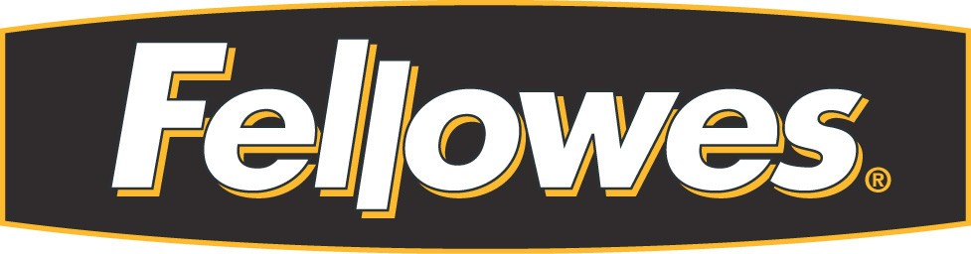

CODE OF CONDUCT
FOR
SUPPLIERS

- General Principles. Fellowes is committed to ethical business practices in its own facilities and its supplier’s facilities. To define these practices and provide a means of monitoring adherence to these practices, Fellowes has prepared this Code of Conduct (“Code”). Adherence to this Code will not only enhance the communities in which our products are manufactured, but will also strengthen the relationships with our mutual customers.
  - This Code applies to the suppliers of all products purchased by Fellowes that are manufactured in countries other than the United States. This Code applies equally to the prime factories as it does to subcontractor and supplier factories (collectively, “Suppliers”).
  - This Code defines the minimum requirements for Suppliers who do business with Fellowes, its subsidiaries, affiliates and joint ventures (“Fellowes”). In all cases, the demonstrated actions should meet or exceed those that are required by the laws and regulation of the applicable country. In addition, Fellowes encourages Suppliers to take additional steps not covered in this Code to improve working conditions, employment practices and environmental protection. We expect our Suppliers, at a minimum, to do the following:
    - Comply with all applicable laws and regulations of the countries in which they operate.
    - Abide by fair and humane employment practices.
    - Provide safe and healthy working conditions.
    - Undertake reasonable measures to protect the environment.
C. Inspections: At any time, with advance notice, Fellowes reserves the right to inspect and/or authorize a third party to inspect and audit, without any restrictions, its Suppliers. Inspections will include interviews with several employees of Supplier selected by the inspector to confirm adherence to this Code. If Fellowes determines that any Supplier is in violation of these principles, Fellowes, at its option, reserves the right to:
- require corrective actions within an acceptable time period in order for the business relationship to continue or to resume, and
    - in the case of violations of applicable law, or in the event that other violations of the principals in this Code continue after a reasonable opportunity to remedy such violations, to terminate the business relationship with the Supplier, including cancellation of outstanding purchase orders.
- Documentation: Suppliers are to maintain on site all documentation that may be needed to verify compliance with the laws and regulations of the applicable country of manufacture and this Code. All such documentation is to be made available to Fellowes and/or its designated third party inspector upon request.
- Employment Standards. Suppliers shall comply with applicable laws and industry standards for all employment practices, including working hours, wages and employee benefits. At the time of hiring, all workers shall be clearly informed of the terms of employment as mandated by law, and the Supplier’s own policies and regulations. Suppliers shall not engage in the use of corporal punishment, mental or physical abuse, or verbal abuse. Suppliers shall not use any prison, indentured, bonded or forced labor.
- Child Labor. Suppliers shall employ only workers who meet the legal minimum working age, but in no event less than 14 years of age. For jobs that require greater maturity or pose a higher safety risk, these workers shall be 18 years of age or older. Suppliers shall have legitimate substantiation of the date of birth of each worker. This minimum working age requirement is applicable to all work, whether performed in part or in whole at home or in cottage industries.
- Health And Safety. In addition to meeting or exceeding the general health and safe working conditions (and in the case of workers living in Supplier provided dormitories, living conditions) as required by law, Suppliers are to ensure the following at a minimum:
- Health and Safety Education: Workers are to be educated routinely on the importance of health and safety, and good sanitation. Suppliers are to take steps and adopt procedures to prevent accidents and injury including appropriate warning and instruction signs. Workers who use hazardous or flammable materials or operate dangerous equipment must be properly trained.
- Emergency Exits; Evacuation: Easily accessible exits shall be adequate in number, clearly marked and free of obstructions. Emergency exits shall not be locked during working hours. Trained supervisors shall periodically conduct fire and emergency evacuation drills.
- First Aid and Emergency Care: On-site trained first aid personnel are to be available at all times and first aid services are to be provided to the workers at no cost.
- Additional Safety Measures: Work areas are to be properly light and ventilated. In areas where excessive dust or airborne chemicals are present appropriate dust masks or respirators must be provided. In areas where the work may pose physical dangers, appropriate protective equipment and clothing shall be provided to the workers at no cost.
- Potable Water and Toilet Facilities: Safe drinking water shall be provided at all times with no restrictions on the consumption of drinking water. Adequate and clean toilet and hand-washing facilities are to be provided.
- Freedom of Movement: Except for customary curfew hours in factory dormitories, workers must be free to leave factory grounds during non-working hours.
- C-TPAT . Supplier shall take reasonable steps to comply with the Customs-Trade Partnership Against Terrorism (C-TPAT) security guidelines published by the United States Department of Homeland Security Bureau of Customs and Border Protection at http://www.cbp.gov/xp/cgov/import/commercial_enforcement/ctpat/

- Environmental Protection. At a minimum, Suppliers are to comply with all applicable environmental laws and regulations of the applicable country of manufacture. In the absence of any applicable laws, Suppliers are to take responsible actions to adopt procedures to ensure the proper protection of the environment through better management, policies, technology and equipment. Whenever possible, Suppliers shall exceed these minimum requirements and ensure the following at a minimum:
  - All hazardous materials and chemicals must be disposed of properly and Suppliers must meet or exceed all wastewater treatment and recycling requirements.
  - Factories are to install the appropriate equipment for proper ventilation and air circulation.
  - In the event hazardous or polluting materials are discharged improperly, Suppliers must notify the appropriate authorities and take immediate actions to contain and clean the discharge.

- Supplier agrees that it shall not and shall cause each of its employees and representatives not to, make, authorize, offer or promise to make or give any money or any other thing of value, directly or indirectly, to any Employee of Fellowes for the purpose of securing any improper or unfair advantage or obtaining or retaining business.

The undersigned Supplier hereby accepts and agrees to be bound by the terms of the Fellowes Code of Conduct.

______________________________ Chop required for Asian Suppliers
[Supplier Name]

_____________________________
[Signature]
Print Name (in English): _______________________
Title: ________________________
Date: ________________________

